Homework 1

Andrew Parrott

April Data Analytics and visualization

Create a stacked column pivot chart that can be filtered by country based on the table you have created.

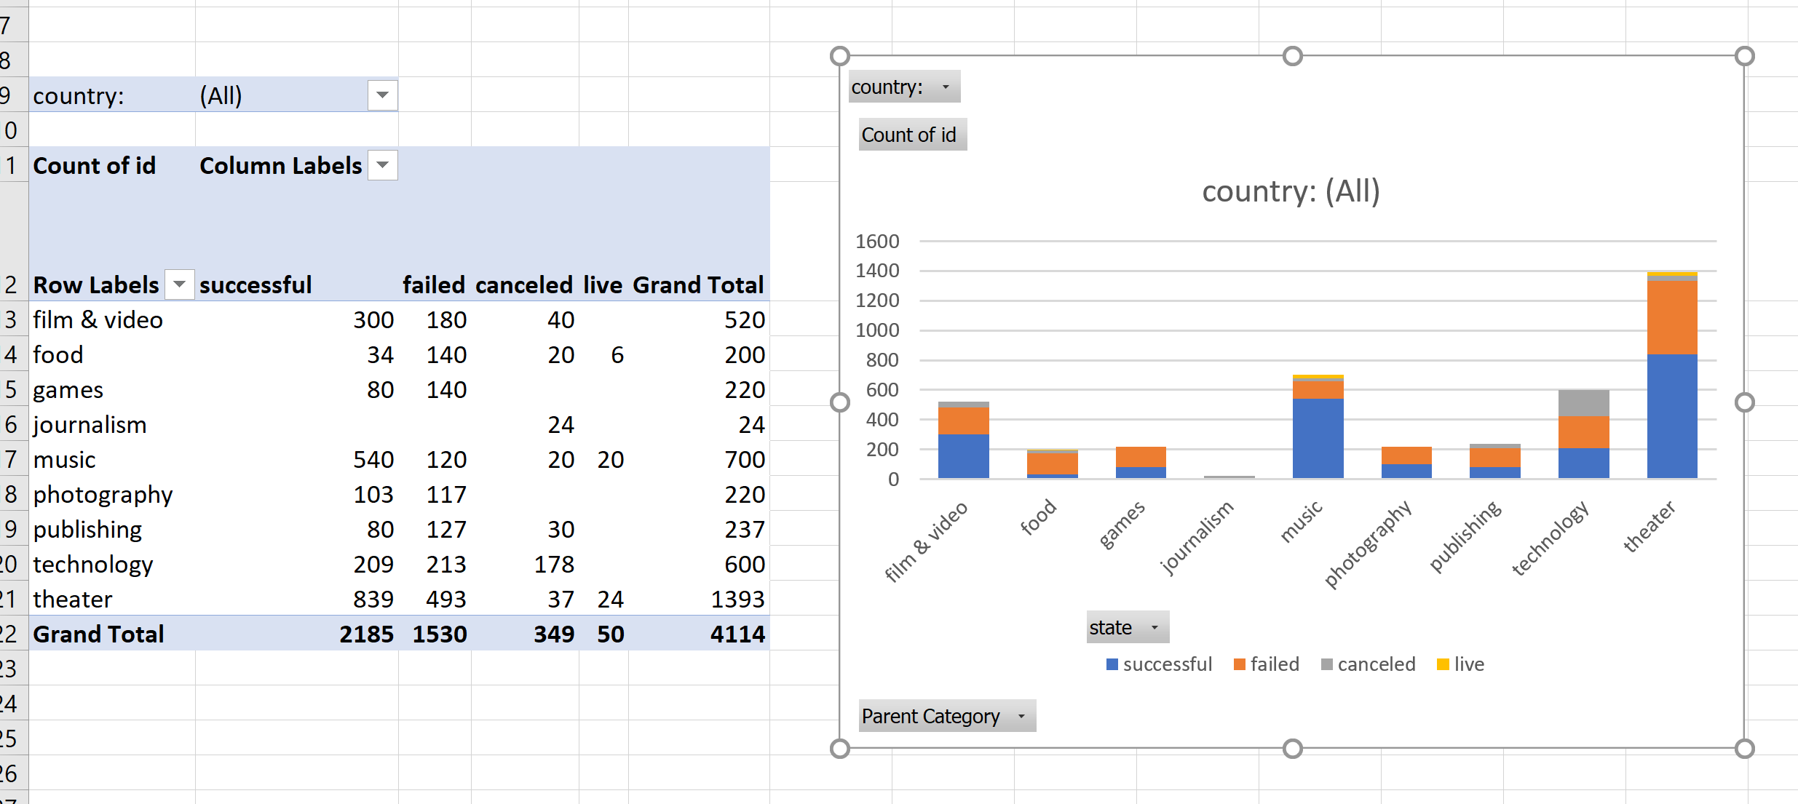

Create a new sheet with a pivot table that will analyze your initial sheet to count how many campaigns were "successful," "failed," "cancelled," or are currently "live" per **sub-category**.

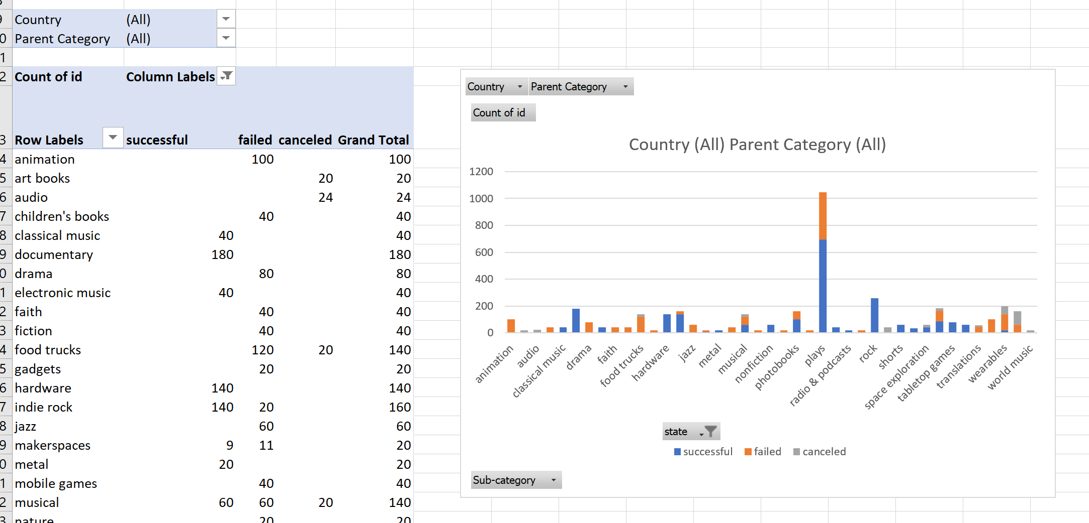

* Create a new sheet with a pivot table with a column of state, rows of Date Created Conversion, values based on the count of state, and filters based on parent category and Years.
* Now create a pivot chart line graph that visualizes this new table.

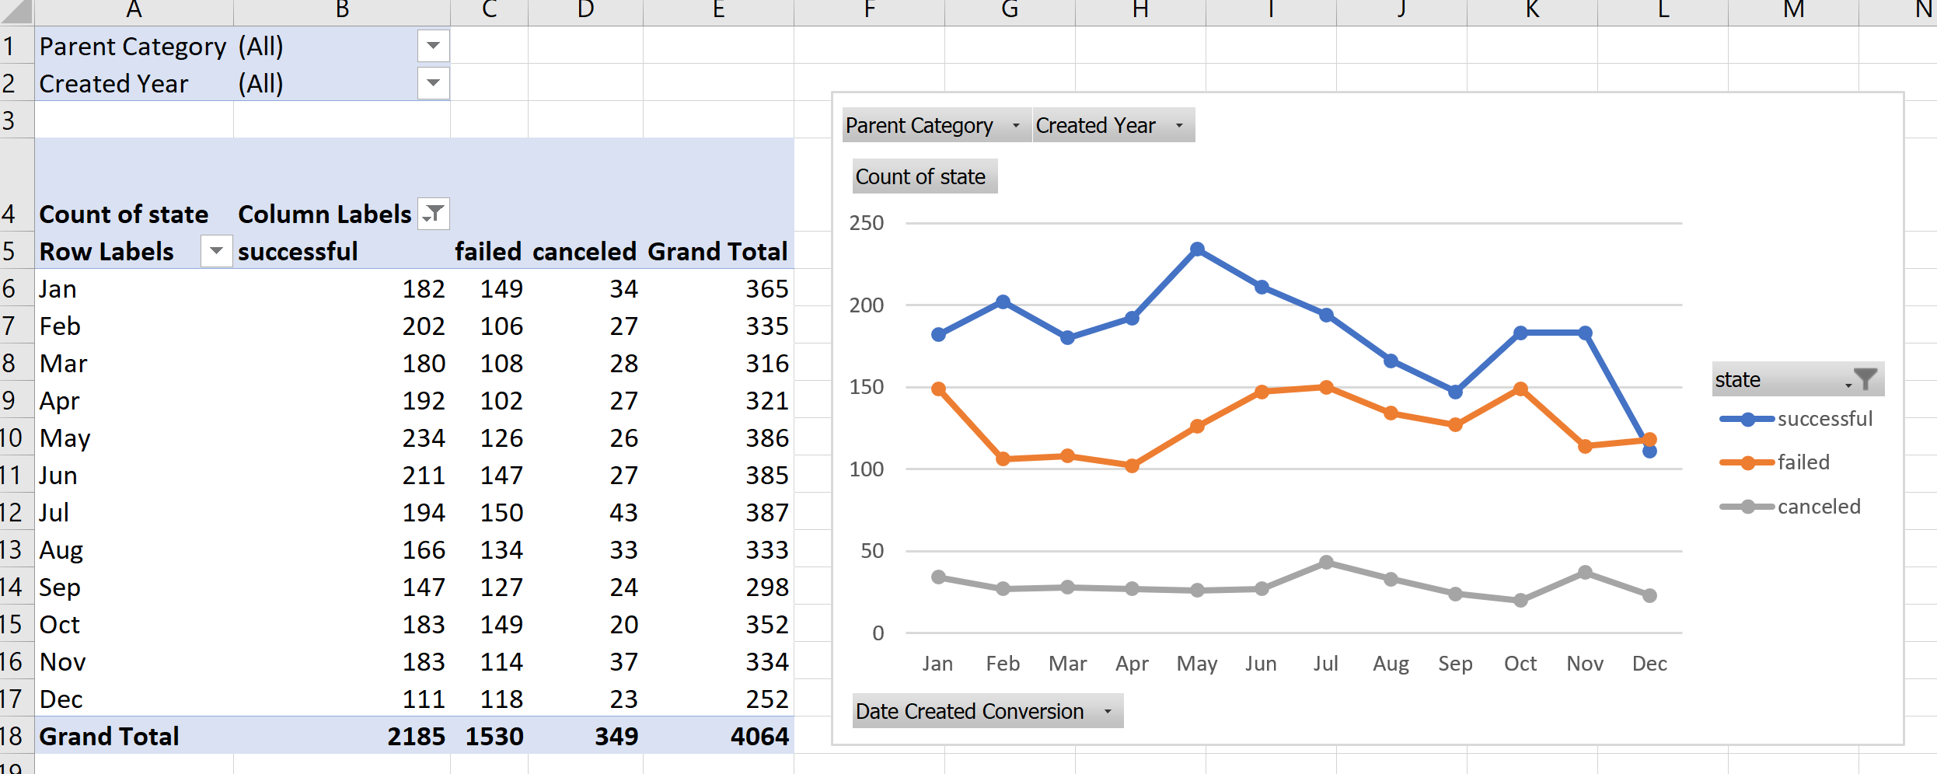

1. What are three conclusions we can make about Kickstarter campaigns given the provided data?

The number of deals spiked way up in 2014, but it took 4.5 years to get to that point. The number of deals on Kickstarter has been declining since the 2014 spike. The percent of total deals that are successful has been declining over the life of the company. Theater category has the greatest count of successful deals between 2014 and 2017

1. What are some of the limitations of this dataset?

It ends over a year ago. I don’t know how it was attained, so I can’t verify it’s accuracy. I can’t calculate skew of donation size, see the mean or mode of donations.

1. What are some other possible tables/graphs that we could create?

Games have been doing better over time

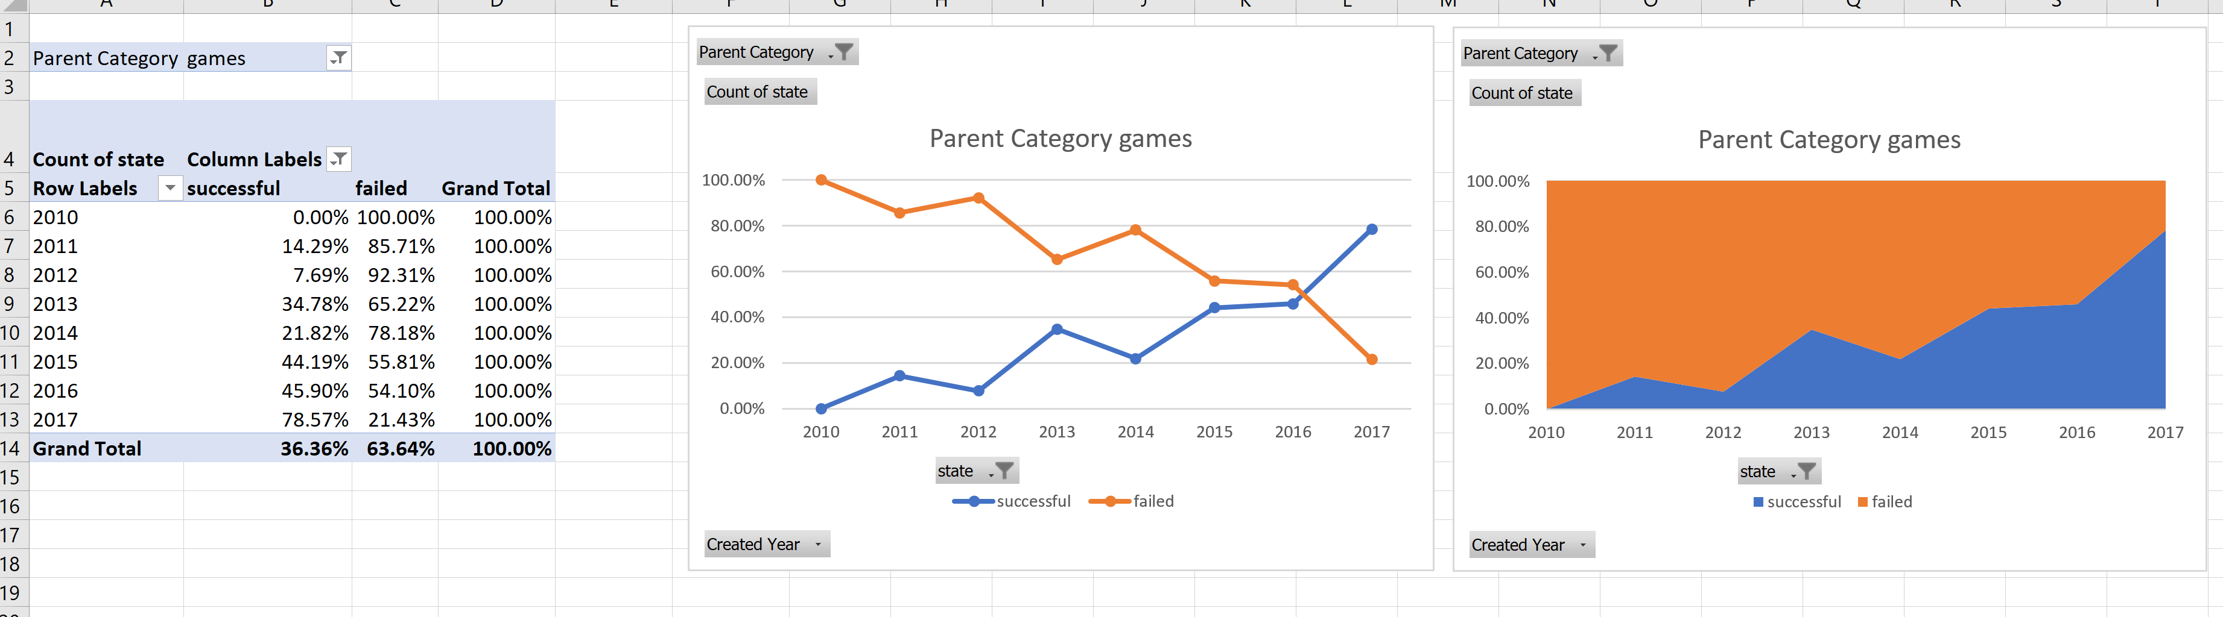

Over time, the things that are successful have changed

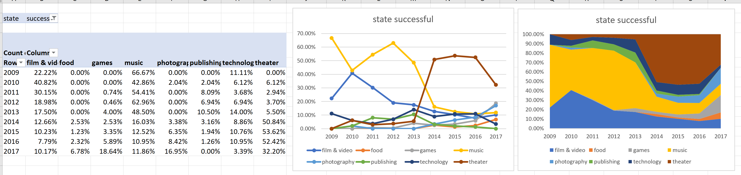

Theater stands out with a high count of successes

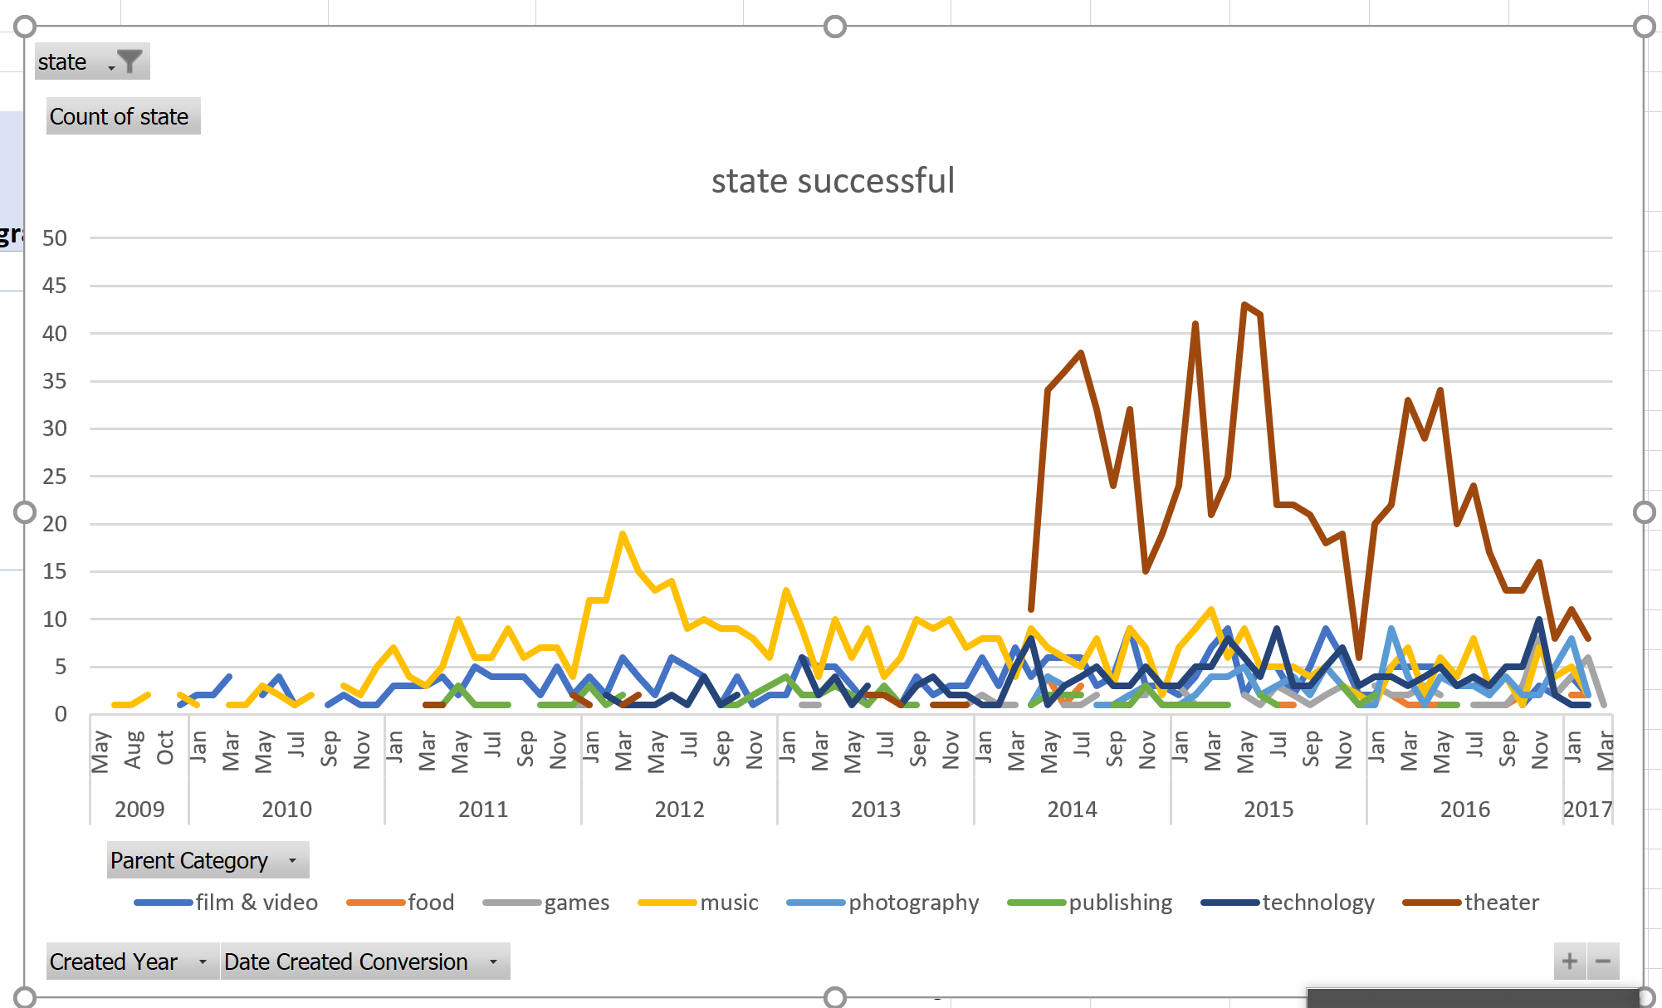

Bonus:

